CSA1505 - CLOUD COMPUTING AND BIG DATA ANALYTICS
Experiment-7

7. Create a simple cloud software application for Students Attendance System using any Cloud Service Provider to demonstrate SaaS include the necessary fields such as name of the students, course, present , Absent, course attendance, OD request, grade, attendance percentage, etc.
AIM:
To develop a simple Student Attendance System using Zoho Creator (Cloud Service Provider) to demonstrate the Software as a Service (SaaS) model. The application manages student attendance records, tracks attendance percentage, processes OD (On Duty) requests, and assigns attendance grades through a cloud-based platform.
PROCEDURE:
Log in to Zoho Creator.
Create a new application named Student Attendance System.
Design a form with the following fields:
- Student Name
- Register Number
- Course
- Total Classes Conducted
- Classes Attended (Present)
- Classes Missed (Absent)
- Course Attendance
- OD (On Duty) Request (Yes/No)
- Attendance Percentage
- Attendance Grade
- Attendance Date
Configure the required fields using text boxes, number fields, date fields, and drop-down lists.
Create workflows to:
- Automatically calculate the Attendance Percentage.
- Display the Attendance Grade based on the attendance percentage (Excellent, Good, Average, Poor).
- Automatically set the Attendance Date to the current date.
Save and publish the application.
Enter sample student attendance details and submit the form.
Verify that the attendance percentage, attendance grade, and attendance records are calculated and stored correctly.

INPUT:
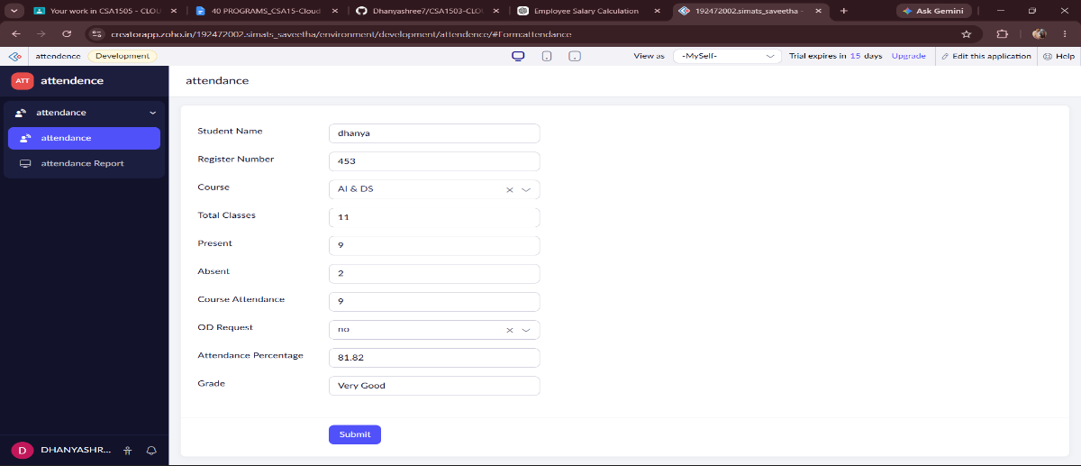
OUTPUT:
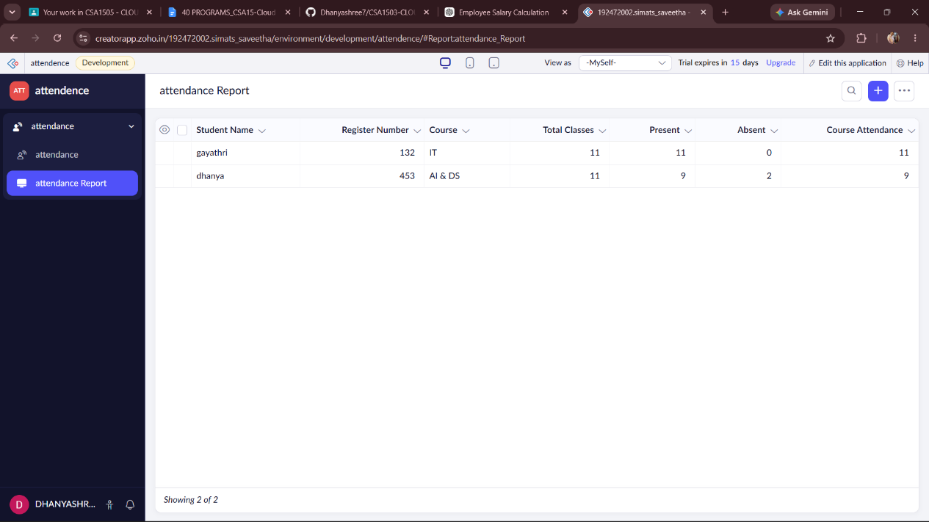
DESIGN:
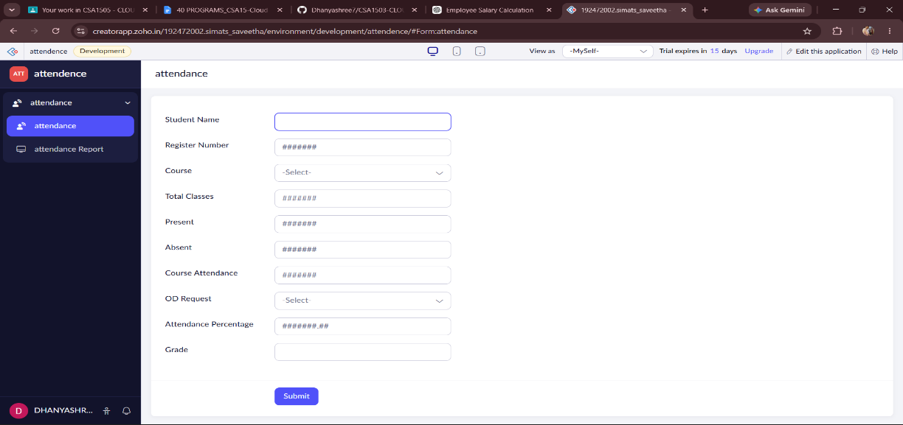

WORKFLOW:
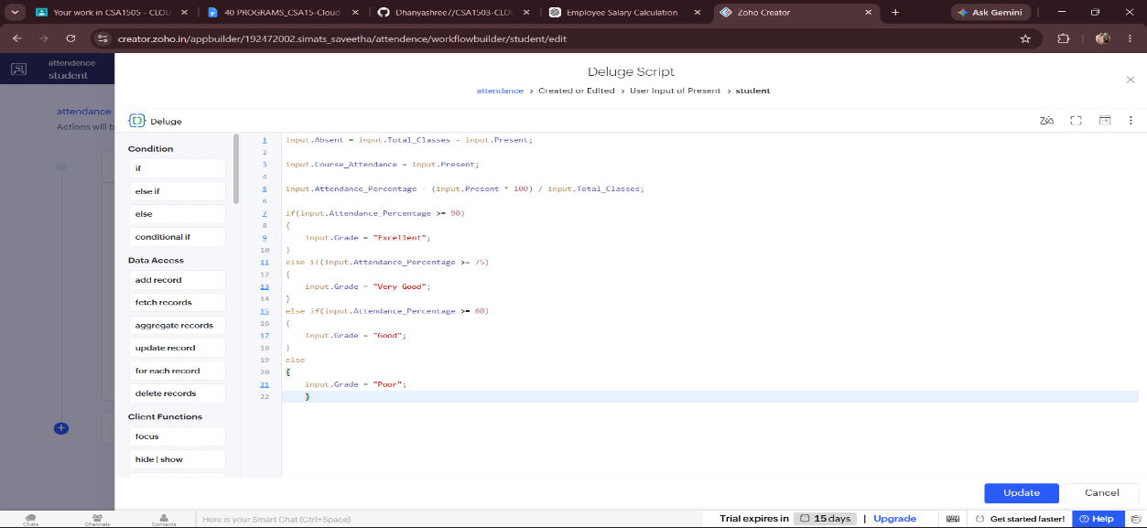
RESULT:
A cloud-based Student Attendance System was successfully developed using Zoho Creator. The application stores student attendance details, calculates the attendance percentage, manages OD requests, assigns attendance grades, and maintains attendance records efficiently. This demonstrates the implementation of the Software as a Service (SaaS) model using a cloud platform.

